Fox Hunt Arena

Rev - E

**INTRO**

It’s the year **2112**, and you find yourself on FOXHUNT, the world’s most popular game show.

But Foxhunt is not like any other game show. Of course there is prize money, Up to a million dollars, but in order to win, you must survive 7 rounds in the arena!  
  
It will not be easy. There are three Hunters trying to kill you. You must fight through each round and collect the 2 codes that will set off the explosive charge placed in each Hunter’s neck.

There are objects stored in stations scattered around the arena that can help you. If you find yourself in a tight situation, use the Crossbow that you found. But watch out, someone dropped an XG-**7** Laser-rifle into the Arena. Find it first!  
  
Run fast, collect the cash, find every station, and fend off the Hunters before they find you….

Don’t let the audience down. give ‘em a good show.   
 ...LET THE GAME BEGIN!

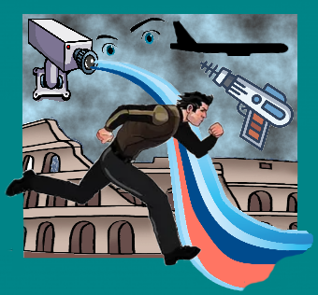

**Game play**

As the Fox, your goal is survive seven rounds in the Arena.   
  
At the start of the first round, you are defenseless. You have only your fleet feet. Find the key to activate the Stations. The stations in this first round contain health. Later rounds will include additional helpful items.

There are three different arenas, and at the start of each new arena, you must find the key that unlocks these new stations. You must find and open every station to complete the round and move on.  
  
Once you find the crossbow, you can defend yourself. The cross bow is limited and takes time to reload. And The hunters will try to avoid your shot. If you injure them twice and they are out for the round…but they will be back and healthy for the next round!

The Arena wall and buildings are protected by an electric fence. The audience doesn’t want you escaping! Touching the walls will shock you and immobilize you for a time. If you try to get out, you will just be returned to the starting point.

Surviving each round adds cash to your winnings. As the rounds get harder, the reward gets bigger. And grab the cash along the way, but don’t delay, time is against you too.

The audience is rooting for you, in fact, one fan has bribed an official to sneak in a secret weapon: the XG-**7** Laser-rifle!

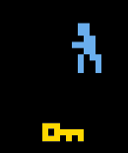****

**Game Start**

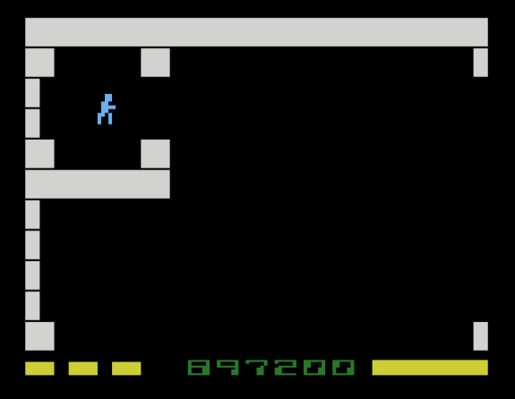The Fox will start each round in his corner, the upper left field of the arena. In rounds 1 & 2, there are 9 fields in the arena, rounds 3 & 4 have 16 and 5, 6 & 7 have 25 fields. Each field is protected by one of the Hunters. And they are more diligent when you are near a Station.

Your winnings! Collect Cash and bonus points for each round, but time is not your friend. Your payout also depends on how fast you complete the game.

You have 8 health points, shown here. Don’t let it get to zero. Some stations give you more, but watch out, not all do!

Carl bob nova  
Each hunter gets 2 injuries per round. Their health counters are shown here.   
When injured twice, they are out for they round.

Use the arrow keys to move and the space key to fire, or a joystick on a real Atari 2600   
Note: The Arrow or laser will fire in the direction the player last moved or is moving.

Moving off the top, right, left or bottom side of the field will jump you to the next field.   
  
Try not to touch the electric- fortified walls!

**Objects**

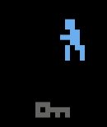

Fox Nova Bob Carl Station - filled

C:\Users\Mikes\Desktop\Atari Games\Mikes Atari Games\Manual\Bow.pngC:\Users\Mikes\Desktop\Atari Games\Mikes Atari Games\Manual\Shield.pngC:\Users\Mikes\Desktop\Atari Games\Mikes Atari Games\Manual\ShockProof.pngC:\Users\Mikes\Desktop\Atari Games\Mikes Atari Games\Manual\Cash.png

Key Bow Laser Rifle Code parts Shield Force-Field Cash

**Objects**

KEY:

The key is randomly placed in one of the fields in rounds 1, 3 and 5. Find it to activate the stations. Once found, the stations in the next round will also be active.  
  
Bow:

The bow allows you to shot in any direction, once every few seconds. Use it wisely

XG-7 Laser Rifle

The laser rifle shoots fast and reloads faster than the bow. It is not easy to get.

Code A and Code B

You need to find both of these codes. Together, they allow you to ignite the charges in the hunter’s necks and win the game. It’s the only way out…alive.

Shield:

The shield will protect you from the hunters. It lasts a few fields and then  
you are vulnerable again. You can shoot, but cannot pick up cash.

Force Field

You can pass though and over the electric fences and walls without harm. This valuable object lasts until you access the next station.

**Ending the game**

The game ends in one of two ways:

You survive all seven rounds and find the two Code Pieces, releasing the deadly charges in the Hunter’s necks. You go home a rich person…

… Or The Hunters kill you and the winnings go to your surviving family.

**Options**

Left difficulty switch: Start each round with full health   
right difficulty switch: Do not get frozen when touching the wall

On the stella emulator, these are F5/F6 and F7/ F8.

F2 causes a restart

**Exit**

Fox Hunt Arena is based on the Atari 400/800 game written by Michael Bachman in 1983. That game was in turn based on the movie Fox Hunt. Directed by Douglas Bachman, the movie premiered at the Horseheads High School auditorium in 1982.

Fox Hunt was a smash hit and was soon found by Hollywood and remade as “the Running Man”, starring Arnold Schwarzenegger; replacing Jim Good as the Fox. As is true for most remakes… the original was better.

**Install**

You can run this game on you PC using the Atari 2600 emulator called Stella.   
Find the Windows or Mac installation file online. Download it and follow the instructions. <https://stella-emu.github.io/downloads.html>  
  
place the Fox_Hunt_Arena.bin file on your desktop or in any folder you wish.   
  
Launch Stella and file select the Fox hunt arena game and press run! Enjoy

By:

Artisan Retro Games

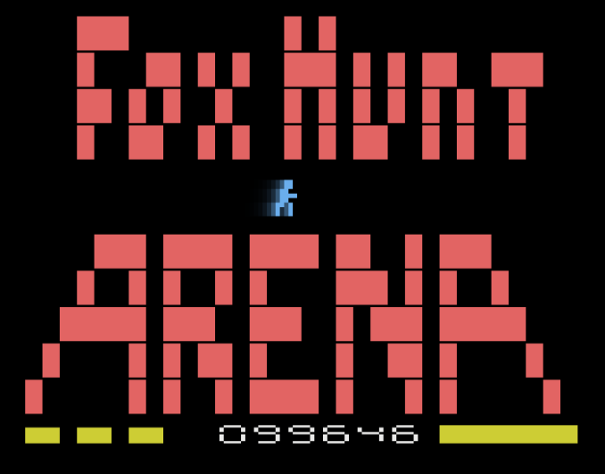

Copyright: 2023